# Filmolokhia – فيلملوخية

## Definition

**# Source**: **Chatgpt (GPT-5-Standard) at [8/27/2025]**

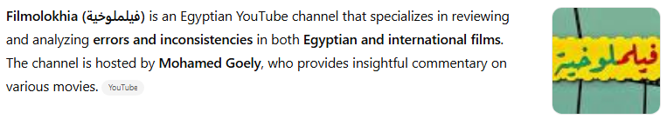

**Filmolokhia (فيلملوخية)** is an Egyptian YouTube channel that specializes in reviewing and analyzing **errors and inconsistencies** in both **Egyptian and international films**. The channel is hosted by **Mohamed Goely**, who provides insightful commentary on various movies.([YouTube](https://www.youtube.com/watch?v=_fkyAP1TLeE&utm_source=chatgpt.com))

## Channel Overview

**# Source**: **Chatgpt (GPT-5-Standard) at [8/27/2025]**

* **Name**: Filmolokhia (فيلملوخية)
* **Host**: Mohamed Goely
* **Subscribers**: Approximately 212K
* **Content**: Film error reviews and analyses
* **Language**: Arabic
* **Platform**: YouTube([YouTube](https://www.youtube.com/%40Filmolokhia/search?utm_source=chatgpt.com), [YouTube](https://www.youtube.com/channel/UCDinJ1eNpjgVYb5DtttKYJA/posts?utm_source=chatgpt.com), [YouTube](https://www.youtube.com/watch?v=YREcuIMxekk&utm_source=chatgpt.com))

## Content Focus

**# Source**: **Chatgpt (GPT-5-Standard) at [8/27/2025]**

Filmolokhia's videos delve into various aspects of films, including:

* **Plot inconsistencies**: Identifying contradictions within the storyline.
* **Continuity errors**: Noting discrepancies in scenes or sequences.
* **Historical inaccuracies**: Highlighting factual errors in films based on real events.
* **Cultural misrepresentations**: Pointing out portrayals that misrepresent cultures or traditions.([Facebook](https://www.facebook.com/filmolokhia/?utm_source=chatgpt.com))

The channel aims to provide viewers with a deeper understanding of films by pointing out these overlooked details.

## Popular Videos

**# Source**: **Chatgpt (GPT-5-Standard) at [8/27/2025]**

Some of the channel's notable videos include:

* **"أخطاء فيلم النمر و الأنثى"**
* **"أخطاء فيلم امرأة هزت عرش مصر"**
* **"أخطاء فيلم رسالة إلى الوالي"**([YouTube](https://www.youtube.com/%40Filmolokhia?utm_source=chatgpt.com), [YouTube](https://www.youtube.com/watch?v=YREcuIMxekk&utm_source=chatgpt.com))

These videos have garnered significant views, reflecting the audience's interest in film analysis.

## Social Media Presence

**# Source**: **Chatgpt (GPT-5-Standard) at [8/27/2025]**

Filmolokhia maintains an active presence on various social media platforms, allowing fans to engage with the content and stay updated on new releases:

* **Facebook**: [Filmolokhia Facebook Page](https://www.facebook.com/filmolokhia/)
* **Instagram**: [@filmolokhia](https://www.instagram.com/filmolokhia)
* **TikTok**: [@mohamedgoely](https://www.tiktok.com/@mohamedgoely)([YouTube](https://www.youtube.com/watch?v=_fkyAP1TLeE&utm_source=chatgpt.com))

## Summary Table

**# Source**: **Chatgpt (GPT-5-Standard) at [8/27/2025]**

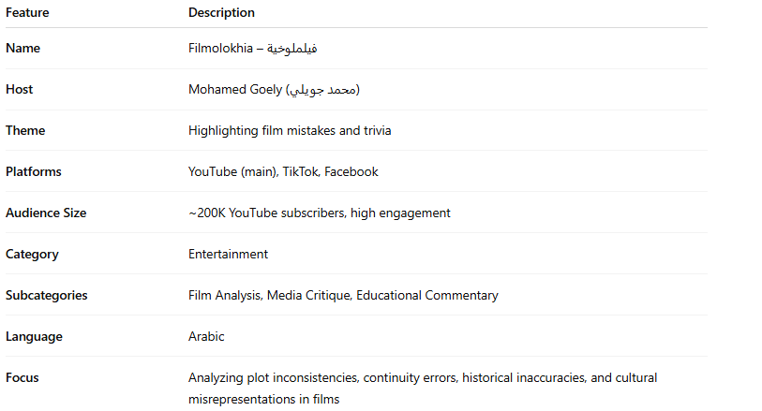

| **Feature** | **Description** |
| --- | --- |
| **Name** | Filmolokhia – فيلملوخية |
| **Host** | Mohamed Goely (محمد جويلي) |
| **Theme** | Highlighting film mistakes and trivia |
| **Platforms** | YouTube (main), TikTok, Facebook |
| **Audience Size** | ~200K YouTube subscribers, high engagement |
| **Category** | Entertainment |
| **Subcategories** | Film Analysis, Media Critique, Educational Commentary |
| **Language** | Arabic |
| **Focus** | Analyzing plot inconsistencies, continuity errors, historical inaccuracies, and cultural misrepresentations in films |